**Year 10 Chemical Science Exam Revision**

1. Two different types of atoms are isolated and their atomic and mass numbers are identified.

If the atoms can be represented as  and 

Determine (using a Periodic Table where necessary):

1. Number of **protons** in each type of atom

X: **38**

D: **53**

1. Number of **valence electrons** of each atom

X: **2**

D: **7**

1. the **ion** that each atom would be expected to produce if they reacted together.

**X+2 D-1**

1. the **formula of the compound** made by reacting X and D together.

**XD2**

1. **Sketch** the two isotopes of oxygen  and  showing the sub-atomic particles contained in each isotope.

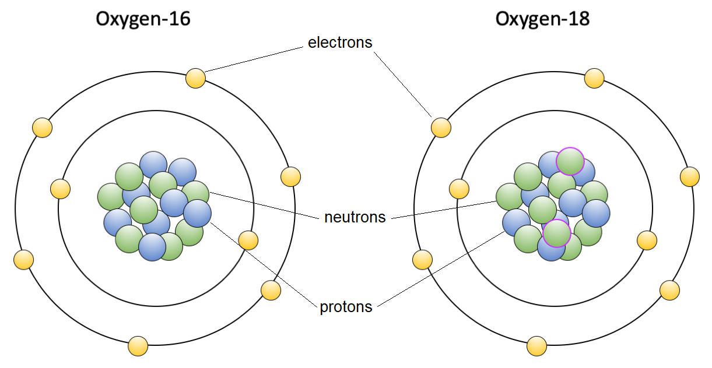

1. **Copy and complete** the following table:

|  |  |  |  |  |
| --- | --- | --- | --- | --- |
| Particle | Number of Protons | Number of Neutrons | Number of Electrons | Atomic No. |
| 14  7  N | **7** | **7** | **7** | **7** |
| 23  11  Na+ | **11** | **12** | **10** | **11** |
| 35  17  Cl - | **17** | **18** | **18** | **17** |
| **29**  **14**  **Si+4** | 14 | 15 | 10 | **14** |

1. Complete the following table

|  |  |  |
| --- | --- | --- |
| Atom/ion | Electron Configuration | Electron Configuration diagram |
| Lithium | **2, 1** |  |
| Nitrogen | **2, 5** |  |
| Argon | **2, 8, 8** |  |
| Magnesium ion | **2, 8** |  |

1. Why can it be said that the fluoride ion is, in one way, similar to the noble gas neon?

**The fluoride ion is a fluoride atom with an additional electron to complete fluorine’s outside shell. The makes a total of 10 electrons which is the same electron configuration as Neon.**

1. Complete the table by putting in the **formulas**. The first one has been done for you.

|  |  |  |  |  |  |  |
| --- | --- | --- | --- | --- | --- | --- |
|  | **Negative Ions** | | | | | |
| **Positive Ions** | Chloride | Sulfide | Hydroxide | Nitrate | Sulfate | Phosphate |
| Potassium | ***KCl*** | **K2S** | **KOH** | **KNO3** | **K2SO4** | **K3PO4** |
| Calcium | **CaCl2** | **CaS** | **Ca(OH)2** | **Ca(NO3)2** | **CaSO4** | **Ca3(PO4)2** |
| Tin (II) | **SnCl2** | **SnS** | **Sn(OH)2** | **Sn(NO3)2** | **SnSO4** | **Sn3(PO4)2** |
| Lead (II) | **PbCl2** | **PbS** | **Pb(OH)2** | **Pb(NO3)2** | **PbSO4** | **Pb3(PO4)2** |
| Iron (III) | **FeCl3** | **Fe2S3** | **Fe(OH)3** | **Fe(NO3)3** | **Fe2(SO4)3** | **FePO4** |
| Ammonium | **NH4Cl** | **(NH4)2S** | **NH4OH** | **NH4NO3** | **(NH4)2SO4** | **(NH4)PO4** |

1. Give the number of protons and neutrons in each of the following.

|  |  |  |  |  |  |  |  |  |  |
| --- | --- | --- | --- | --- | --- | --- | --- | --- | --- |
| $${}_{30}^{66}{Zn}$$ | **30** | protons, | **36** | neutrons | $${}_{19}^{39}K$$ | **19** | protons, | **20** | neutrons |
| $${}_{44}^{101}{Ru}$$ | **44** | protons, | **57** | neutrons | $${}_{25}^{55}{Mn}$$ | **25** | protons, | **30** | neutrons |
| $${}_{82}^{207}{Pb}$$ | **82** | protons, | **125** | neutrons | $${}_{17}^{35}{Cl}$$ | **17** | protons, | **18** | neutrons |
| $${}_{88}^{226}{Ra}$$ | **88** | protons, | **138** | neutrons | $${}_{92}^{238}U$$ | **92** | protons, | **146** | neutrons |

1. Give the **chemical names** for the following formulae.

**FORMULA NAME**

H2SO4 **Sulfuric acid**

HNO3 **Nitric acid**

CO2  **Carbon dioxide**

N2 **Nitrogen gas**

**FORMULA NAME**

H3PO4 **Phosphoric acid**

CH3COOH **Ethanoic acid or acetate or vinegar**

SO2  **sulfur dioxide**

Cl2 **chlorine gas**

1. State if each of the following statements are true or false. If they are false, rewrite the statement so that it is true.
2. Protons and neutrons have approximately the same mass. **True**
3. In a neutral atom, the number of protons equals the number of neutrons. **False**
4. The mass of an electron is one hundredth the mass of a proton. **False**
5. The nucleus consists of protons and neutrons **True**
6. The atom is mainly empty space **True**
7. Most of the mass of an atom exists in the electron cloud **False**
8. A compound contains two or more elements mixed together. **False**
9. Classify the following as having ionic or metallic bonds
10. NaCl **ionic**
11. Ag **metallic**
12. Lead (II) Iodide **ionic**
13. Magnesium Bromide **ionic**
14. Brass **metallic**
15. **Describe** in terms of electron transfer and ion formation the **ionic** **bond** that results when Na and S react together to form Na2S.

**Each sodium atom loses an electron to become a sodium ion, turning its 2nd shell into a full valence shell.**

**Each sulfur atom receives two electrons to complete its 3rd shell becoming sulfide.**

**The two electrons that sulfur receives to become sulfide is from two sodium atoms who have lost electrons to become sodium ions.**

**The electrostatic charge from the two sodium atoms losing electons and sulfur gaining electrons is what attracts the sodium ions to the sulfide.**

1. Write formula and name for each ionic compound formed between the listed pairs of ions.

|  |  |  |  |
| --- | --- | --- | --- |
|  | Ion pairs | Formula | Name |
| 1 | K+ and I- | **KI** | **Potassium iodide** |
| 2 | Ca2+ and F- | **CaF2** | **Calcium Fluoride** |
| 3 | Al3+ and N3- | **AlN** | **Aluminium Nitride** |
| 4 | NH4+ and Cl- | **NH4Cl** | **Ammonium Chloride** |
| 5 | Na+ and SO32- | **Na2SO3** | **Sodium Sulfite** |
| 6 | Ba2+ and OH- | **Ba(OH)2** | **Barium Hydroxide** |
| 7 | NH4+ and CO32- | **(NH4)2CO3** | **Ammonium Carbonate** |
| 8 | Ti2+ and Br- | **TiBr2** | **Titanium Bromide** |
| 9 | V3+ and S2- | **V2S3** | **Vanadium Sulfide** |
| 10 | Co3+ and NO3- | **Co(NO3)3** | **Cobalt (III) Nitrate** |

1. Write ion pairs and formula for each ionic compound listed below and then use a solubility table to determine the solubility (soluble or insoluble) of the substance

|  |  |  |  |  |
| --- | --- | --- | --- | --- |
|  | Name | Ion pair | Formula | Solubility |
| 1 | Lithium bromide | **Li+1 Br-1** | **LiBr** | **Soluble** |
| 2 | Potassium phosphide | **K+1 P-3** | **K3P** | **Not in table** |
| 3 | Magnesium oxide | **Mg+2 O-2** | **MgO** | **Not in table** |
| 4 | Ammonium sulphide | **NH4+1 S-2** | **(NH4)2S** | **Soluble** |
| 5 | Aluminium nitrite | **Al+3 NO2-1** | **Al(NO2)3** | **Not in table** |
| 7 | Calcium phosphate | **Ca+2 PO4-3** | **Ca3(PO4)2** | **Insoluble** |
| 8 | Lead (II) acetate | **Pb+2 CH3COO-1** | **Pb(CH3COO)2** | **Soluble** |
| 9 | Manganese (IV) nitride | **Mn+4 N-3** | **Mn3N4** | **Not in table** |
| 10 | Nickel (II) cyanide | **Ni+2 CN-1** | **NiCN2** | **Not in table** |

1. Complete a table showing the properties of metallic and ionic substances.

|  |  |  |
| --- | --- | --- |
| **Properties** | **Metallic** | **Ionic** |
| **Physical** | **Malleable and ductile** | **Brittle and Hard** |
| **Bonding** | **Delocalised Electrons and positive ions** | **Lattice structure made up of alternating positive and negative ions** |
| **Conductivity** | **High for solids** | **Not as solids but does when molten** |
| **Melting Point** | **High** | **Low to High** |

1. Complete the following sentences.

Metal atoms **lose** electrons to form **positive** ions.

The **group** on the periodic table tells us how many electrons are in the outer shell of an element.

The **period** on the periodic table tells us how many shells contain electrons.

Non-metals become **less** reactive as the periods increase.

Metals become **more** reactive as the periods increase.

On the periodic table, Potassium is found in group **1** and period **4**.

1. Describe 4 ways that the rate of a chemical reaction can be increased.

* Increasing the temperature of reactants. This increases the number of collisions occurring meaning a greater opportunity of successful collisions with more energy.
* Increasing the concentration of reactants means there are more available to collide with each other. This increases the number of successful collisions.
* Using a catalyst to create an alternative pathway with a lower energy required for a successful collision to occur.
* Increasing the surface area of reactants allows more of the reactant to be exposed to a collision. This results in a higher likelihood of a successful collision

1. Balancing the following Chemical Equations

**2**

**2**

**2**

**2**

**2**

**2**

**2**

**5**

**2**

**8**

**8**

**3**

**2**

**2**

**2**

**2**

**3**

**2**

**3**

**2**

**4**

**2**

**3**

**2**

**2**

**2**

**2**

**4**

**2**

**2**

**2**

**2**

**2**

**2**

**2**

1. Write fully balanced chemical reactions for the following:
2. Hydrochloric acid reacted with aluminium

**6HCl + 2Al → 2AlCl3 + 3H2**

1. Sulfuric acid reacted with lithium hydroxide

**H2SO4 + 2LiOH → Li2SO4 + 2H2O**

1. Nitric acid reacted with calcium carbonate

**2HNO3 + CaCO3 → Ca(NO3)2 + CO2 + H2O**

1. Phosphoric acid reacted with potassium

**2H3PO4 + 6K → 2K3PO4 + 3H2**

1. Sulfuric acid reaction with iron (III) carbonate

**3H2SO4 + Fe2(CO3)3 → Fe2(SO4)3 + 3CO2 + 3H2O**

1. Nitric acid reacted with zinc hydroxide

**2HNO3 + Zn(OH)2 → Zn(NO3)2 + 2H2O**

**Science Inquiry Exam Revision**

Hydrochloric acid reacts with sodium carbonate, producing sodium chloride, water and carbon dioxide gas. The balanced chemical equation for this reaction is:

2HCl + Na2CO3 → 2NaCl + H2O + CO2

A student conducted an experiment where 10.0 mL of 1.0 M acid was added to different masses of sodium carbonate. The student measured the volume of carbon dioxide gas produced in each case and recorded the results in a table:

|  |  |
| --- | --- |
| Mass of Na2CO3 (g) | Volume of CO2 produced (mL) |
| 0.05 | 11.5 |
| 0.10 | 23.0 |
| 0.20 | 46.0 |
| 0.25 | 57.5 |
| 0.30 | 61.2 |
| 0.35 | 61.2 |
| 0.40 | 61.2 |
| 0.45 | 61.2 |

1. Write a suitable hypothesis for this experiment

**As the mass of sodium carbonate reacted is increased the volume of carbon dioxide produced also increases.**

* **Positive statement in 3rd person**
* **Includes both independent and dependent variable**

1. State the independent and dependent variable in this experiment:

Independent: **mass of sodium carbonate reacted**

Dependent: **volume of carbon dioxide produced**

1. State 2 variables which **must** be controlled in order for the experiment to be fair:

* **Concentration of hydrochloric acid**
* **Amount of hydrochloric acid**
* **Temperature of hydrochloric acid**

1. Construct a suitable graph of the data collected by the student on the graph paper provided below.

1. What volume of carbon dioxide gas is produced when 0.15 g of sodium carbonate is added to the hydrochloric acid?

**35 mL**

1. Write an inference as to why the volume of carbon dioxide produced did not increase after 0.3g of sodium carbonate was used.

**0.3 g of sodium carbonate is the maximum amount of sodium carbonate that can fully react with 10g of hydrochloric acid. Any extra sodium carbonate will not react with the hydrochloric acid.**